MVM SAFETY ALERT No 7
EXCAVATOR INCIDENT

Summary information -
- On Tuesday 22 September 2009 - The Driver/Operator of an Hydraulic Wheeled Excavator sustained a Fractured Skull and a collapsed Lung after he was ejected through the front of the Cab of his vehicle, on the MVM M1 widening J25-28 Project
What happened -
- The Excavator had been travelling between Two Gantry Base locations along the Project’s Central Reserve work area, with the Excavator’s Dipper Arm in a raised position, the top of which was measured (post incident) at 6.50m above ground level
- As the Excavator reached the 1st existing Motorway Over-bridge, the top of the Dipper Arm struck the edge of the Soffit of the Bridge causing the Excavator to come to a sudden halt. The point of impact on the soffit of the Motorway Over-bridge was measured (post incident) at 6.15m above ground level (see photograph below left / on next page)
- The Driver/Operator (abbr. IP) was thrown forwards, over the Floor Mounted Steering Column and through the front of the Cab of the Excavator. The front of the Cab was open, and the window was in a raised position.
- IP came to rest with his Head face down, his Left Arm beneath his Torso and his Feet in a raised position between the Cab and Front Blade adjacent to the Excavator’s near side Front (Rubber) Wheel
- From his seated position in the Cab, the IP was thrown forward and dropped vertically 1.75m hitting the top edge of the Excavator’s front Blade
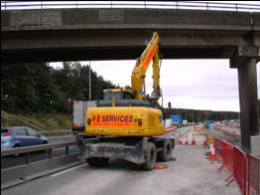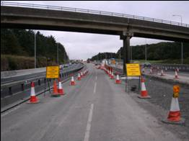
Max. Headroom signs to be added
Photograph taken to show Excavator at the site of the incident Photograph taken to show new barrier and signage configuration
Findings (investigation notes) -
- IP had started work with the Gang on the morning of the incident, as cover for the regular driver/operator who was off
- IP had been briefed onto the written safe system of work produced for Gantry Bases and on the tasks to be undertaken on that day
- It was established that, although a competent operator, one of IP’s core duties involved use of this type of Excavator for mechanical lifting and lowering in his employer’s Storage Yard, at which there are no overhead hazards
- As a consequence, the change in work environment is considered to have been a contributing factor to the incident (i.e. set-up of Excavator and Over-bridge were not factors that had been combined)
- Whilst travelling between the Two Gantry Bases, a distance of approx 1.5km, neither Gang or IP had recognised the need for Banksman control (i.e. acting as an escort)
- Post interview checks revealed that planned overhead structure signage did not have 100% coverage
- It is considered that the Excavator was not travelling at excessive speed
- Evidence suggests that IP had not been wearing the Lap Belt provided
Key learning (issues to be considered each and every day) –
- Human Factors
- Provision of adequate information, instruction, training and supervision
Lessons learned –
- Existing Site Safety Rules – must be adhered to by everyone at all times
- Daily Briefings - effective use is key to success, with benefits especially relevant when delivered to personnel who are either new to a team or have just returned following a period of absence, as well as when site conditions change
- Plant Movements - the partnership of Driver/Operator and Banksmen is Safety Critical and must be used to control all plant movements
- Seat or Lap Belts - must be worn whenever one is provided
- Visual Prompts – A review of existing controls has led to the introduction of an enhanced “barrier and signage configuration” on the Haul Route prior to each over-head structure (see photograph above right / on next page)
- Maintenance – All teams reminded that they are each responsible for maintaining their own work location/area, and the need to replace safety critical elements upon completion of respective work tasks

MVM Safety Alert No 7, issue dated 13 Oct 09

MVM SAFETY ALERT No 7
EXCAVATOR INCIDENT

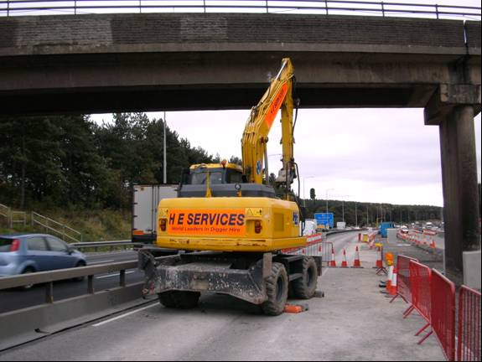
Larger sized photograph taken to show Excavator at the site of the incident

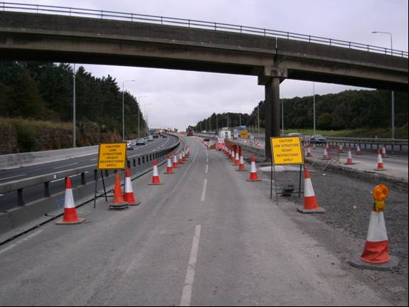
Max. Headroom signs to be added
Larger sized photograph taken to show new barrier and signage configuration
MVM Safety Alert No 7, issue dated 13 Oct 09

